**Exercise 2: E-commerce Platform Search Function**

**1. Understand Asymptotic Notation:**

Big O notation is a way to describe the upper bound of an algorithm's time or space complexity, essentially how the runtime or memory usage grows as the input size increases. It focuses on the dominant term and provides a general understanding of an algorithm's efficiency for large inputs.

**Best, Average, and Worst-Case Scenarios**

**Linear Search (unsorted data)**

* Best Case: O(1) → First item matches.
* Average Case: O(n/2) → Halfway through, simplified to O(n).
* Worst Case: O(n) → Item at the end or not found.

**Binary Search (sorted data)**

* Best Case: O(1) → Middle element matches.
* Average/Worst Case: O(log n) → Each step cuts the list in half.

**Output:**

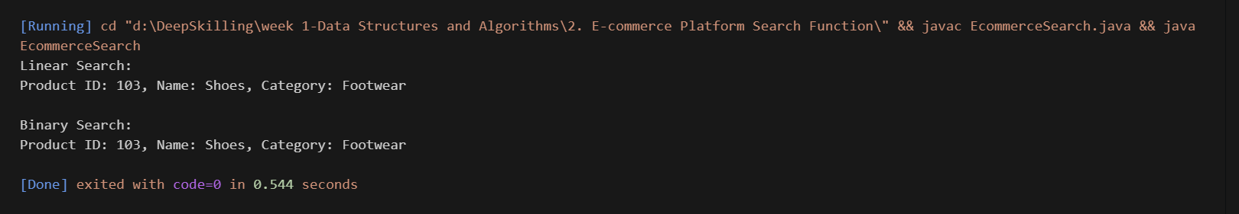

**4. Analysis:**

* **Time Complexity:**

1. Linear Search: O(n)
2. Binary Search: O(log n)

* For an **e-commerce platform** with large inventories **Binary Search** is more suitable due to O(log n) time, but requires the product list to be sorted.